**2 Problem Definition & design thinking**

**2.1 Empathy map**

**Pain:** Too many emails to manage efficiently, difficulty in identifying important emails, and need to constantly adjust priorities throughout the day.

**Does:** skims through email quickly, uses filters and labels to organize emails, and response from promptly to urgent emails.

**Feels:** Frustrated when important emails get buried in the inbox and overwhelmed with the amount of email received daily.

**User:** A busy professional who receives a large volume of emails daily and needs to prioritize and manage them efficiently.

**Says:”** I need and email system that can adapt to my changing priorities throughout the day”

**Think:** I don’t want to waste time shifting through mails that are not important or urgent. I need a system that can help me quickly identify the most important emails.

**Gain:** More times to focus on important task reduce stress and anxiety, and increase productivity.

**2.2 Ideation & Brainstorming Map**

Personalization

Customized email categories based on user preferences

Ability to create custom tags for emails

Machine learning-based email sorting

Option to prioritize certain contacts or senders

User Interface

Clean and simple UI

Ability to customize the layout and colors

Option to view emails by conversation or individually

Analytics

View email open rates and response rates

Insights into email usage patterns

Ability to track the success of email campaigns

Integration

Sync with multiple email accounts (Gmail, Outlook, etc.)

Integration with calendar apps

Ability to add attachments from cloud storage services like Google Drive or Dropbox

Security

Two-factor authentication for account security

Option to encrypt emails

Spam and phishing protection

Smart Features

Suggest replies based on email content

Reminders to follow-up on important emails

Automatic email categorization based on content

Ability to schedule emails to be sent at a later time

**3 RESULT:**

**Home page:**

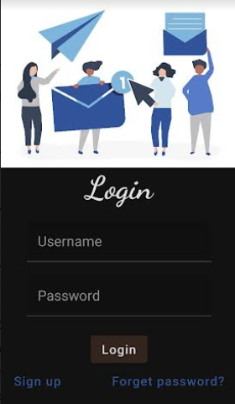

2.2 Ideation & Brainstorming Map

3 RESULT:

Home page: